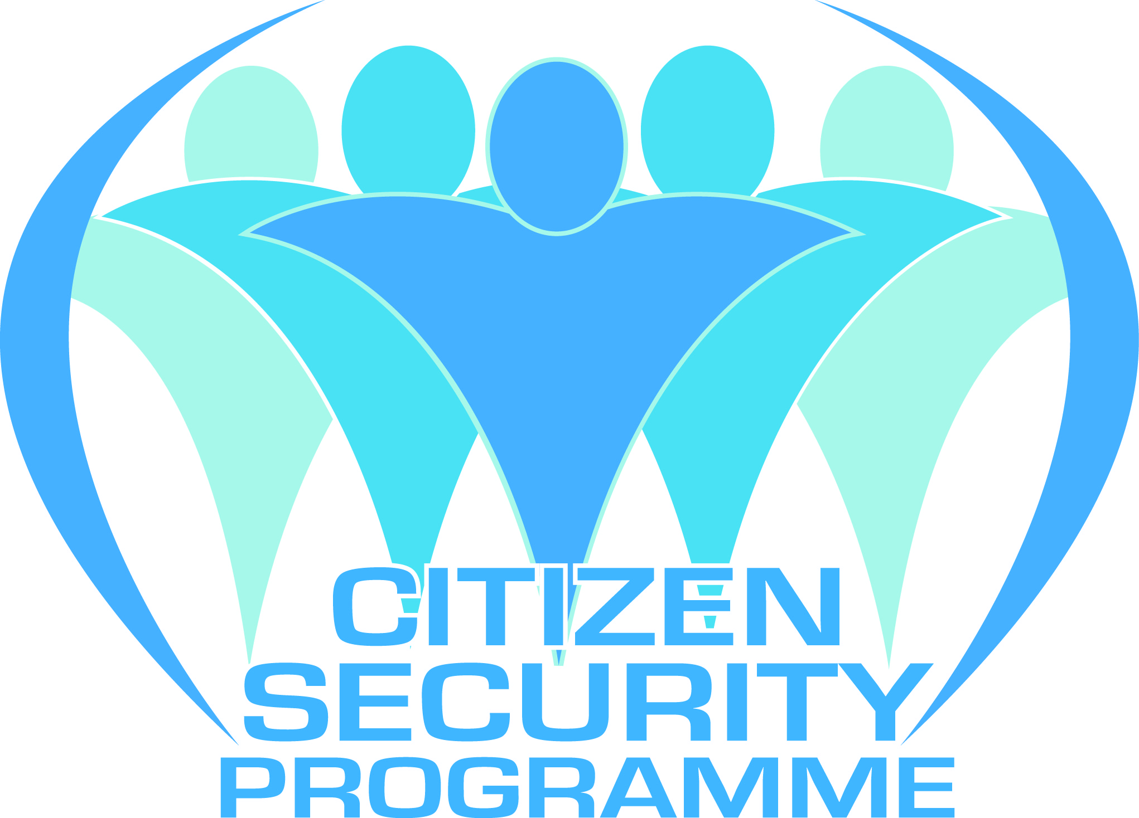

THE MINISTRY OF NATIONAL SECURITY

**Joint Meeting of NGOs to Identify Lessons Learned and Develop Recommendations for Future NGO Capacity-Building Initiatives**

**April 29, 2014**

**CSP Offices**

**Port of Spain, Trinidad**

**DRAFT AGENDA**

8:30 - 9:00 Breakfast

9:00 - 9:10 Review of CSP's Objectives for NGO Capacity Strengthening and Meeting Objectives*, Ms. Ryssa Brathwaite,* Community & Youth Specialist, Citizen Security Programme

9:10 – 9:20 Review of Terms of Reference for M&E Consultants, Consultancy Approach and Activities, *Ansari Ameen*

9: 20 – 10:40 Reflections and Feedback from Individual NGOs (*Maximum 8 Minutes Each*)

* Adult Literacy Tutors Association
* Caribbean Sport for Development Agency
* The Esimaje Foundation
* Kids in Need of Direction
* MOMs for Literacy
* Point Kickboxing Association of T&T
* Trinidad and Tobago Innovative Parenting Support (TTIPS)
* Trinidad Youth Council
* Youth Business of Trinidad & Tobago
* Young Women's Christian Association

1040- 10:50 Break

10:50 - 11:45 Group Discussion, *NGOs, CSP and Consultants*

11:45 - 12:00 Next Steps and the Way Forward, *Ms. Ryssa Brathwaite,* Community & Youth Specialist, Citizen Security Programme

12:00 - 1:00 Lunch

1:00 - 3:00 Training on M&E Database

**Group Discussion Questions for use with 10:50- 11:45 Session**

**Overall Accomplishments and Challenges:**

* Overall, what are the most significant accomplishments resulting from this initiative and CSPs efforts?
* What are the main challenges or obstacles to NGO capacity strengthening?
* What are the main challenges or obstacles to NGO M&E system development?

**Specific Approach to NGO M&E Capacity-Strengthening:**

* Which aspects of the approach worked well?
* Which aspects could have been improved?
* What are your recommendations for future initiatives?

**Sustainability:**

* What mechanisms, actions or systems should be implemented to sustain and build on the gains that have been made to date?
* By CSP?
* By NGOs?
* By other donors and institutions?